|  |  |
| --- | --- |
| CL1002  ***Programming Fundamentals Lab*** | Lab 10  Nested Structures, Composition and Structure array and Filing in C |

# National University of Computer and Emerging Sciences

Fall 2024

# Aims and Objectives

**Aim:**

To understand and implement nested structures, structure composition, arrays of structures, and file handling to manage and organize complex data in C programming.

**Objectives:**

• Understand and implement nested structures to represent hierarchical data types within structures.

• Learn composition to combine multiple structures and achieve modular, organized data modeling.

• Explore the use of arrays of structures to manage collections of related data entries efficiently.

• Implement file handling to read from and write to files, enabling persistent storage and retrieval of structured data in C.

• Practice accessing and manipulating structure members using pointers and array indexing to strengthen data management skills.

### ****Introduction****

Structures are derived data types—they’re constructed using objects of other types. Normally, we use

structure to store the record or the details of any item or entity. Structure members can be variables of the

primitive data types (e.g., int, float, etc.), or aggregates, such as arrays and other structures.

Keyword struct introduces a structure definition

The identifier Chocolate is the structure tag, which names the structure definition and is used with

struct to declare variables of the structure type—e.g., struct Chocolate kitkat, Mars, Jubilee.

Variables declared within the braces of the structure definition are the structure’s members.

Members of the same structure type must have unique names, but two different structure types may

contain members of the same name without conflict.

### ****Section 1: Structures****

The structure in C is a user-defined data type that can be used to group items of possibly different types into a single type. The **struct** keywordis used to define the structure in the C programming language. The items in the structure are called its **member** and they can be of any valid data type. Additionally, the values of a structure are stored in contiguous memory locations like arrays. The difference between an array and a structure is that an array is a homogenous collection of similar types, whereas a structure can have elements of different types stored adjacently and identified by a name.

### **1.1 Declaration of Struct**

struct Choclate{

char Name[20];

float Weight;

int Calories;

float Price;

char ExpiryDate[10];

};

### **1.2 Declaration & Initialization of Struct type Variables**

You can declare the variables before the semi-colon(;) or using a proper declaration syntax like other

variable’s in main();

struct Choclate{

char Name[20];

float Weight;

int Calories;

float Price;

char ExpiryDate[10];

}var1, var2,var3;

Int main()

{

Struct Choclate Kitkat, Mars, Jubliee, mychoclate[3];

}

// OR

struct Choclate myChoclate;

gets(myChoclate.Name);

myChoclate.Weight= 20;

myChoclate.Calories= 500;

myChoclate.Price= 100;

strcpy(myChoclate.ExpiryDate,"01-Feb-2021");

// OR

struct Choclate Jubliee = {"Jubilee",20.50,500,100,"01-Feb-2021"};

}

### **1.3 Declaration & Initialization of Struct type Array**

Int main()

{

// Array of Struct

struct Choclate myFavChoclates[3]; // It is an array of sruct

int i = 0;

while(i<3)

{

gets(myChoclate[i].Name);

scanf("%f",&myChoclate.Weight);

scanf("%d",&myChoclate.Calories);

scanf("%f",&myChoclate.Price);

gets(myChoclate[i].ExpiryDate);

++i;

}

// TO print this array of Struct

i = 0;

while(i<3)

{

puts(myChoclate[i].Name);

printf("%f",myChoclate.Weight);

printf("%d",myChoclate.Calories);

printf("%f",myChoclate.Price);

puts(myChoclate[i].ExpiryDate);

++i;

}

}

### **2.0 Nested Structures**

Nested structure in C is nothing but structure within structure. One structure can be declared inside

other structure as we declare structure members inside a structure. The structure variables can be a

normal structure variable ,array or a pointer variable to access the data. You can learn below concepts

in this section.

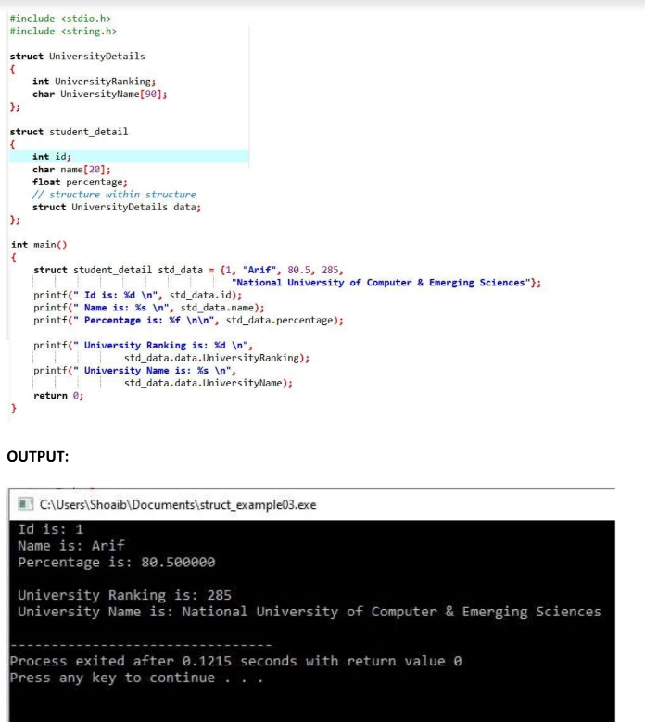

**Another Examples of nested structures**

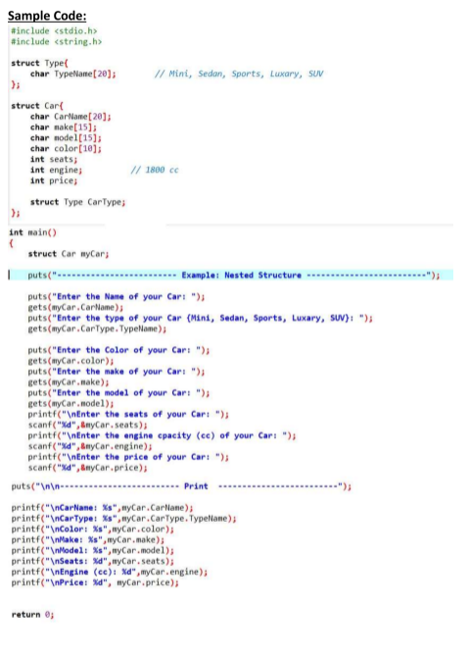

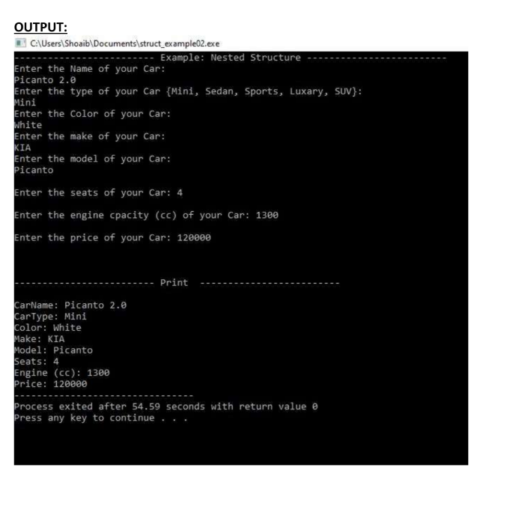

**C File Handling**

**file is a container in computer storage devices used for storing data.**

**Why files are needed?**

* **When a program is terminated, the entire data is lost. Storing in a file will**

**preserve your data even if the program terminates.**

* **If you have to enter a large number of data, it will take a lot of time to enter**

**them all.**

* **However, if you have a file containing all the data, you can easily access**

**the contents of the file using a few commands in C.**

* **You can easily move your data from one computer to another without any**

**changes.**

**Types of Files**

**When dealing with files, there are two types of files you should know about:**

**1. Text files**

**2. Binary files**

**1. Text files**

**Text files are the normal .txt files. You can easily create text files using any**

**simple text editors such as Notepad.**

**When you open those files, you'll see all the contents within the file as plain text.**

**You can easily edit or delete the contents.**

**They take minimum effort to maintain, are easily readable, and provide the least**

**security and takes bigger storage space.**

**2. Binary files**

**Binary files are mostly the .bin files in your computer.**

**Instead of storing data in plain text, they store it in the binary form (0's and 1's).**

**They can hold a higher amount of data, are not readable easily, and provides**

**better security than text files.**

**File Operations**

**In C, you can perform four major operations on files, either text or binary:**

**1. Creating a new file**

**2. Opening an existing file**

**3. Closing a file**

**4. Reading from and writing information to a file**

**Working with files**

**When working with files, you need to declare a pointer of type file. This**

**declaration is needed for communication between the file and the program.**

**FILE *fptr;**

**Opening a file - for creation and edit**

**Opening a file is performed using the fopen() function defined in**

**the stdio.h header file.**

**The syntax for opening a file in standard I/O is:**

**ptr = fopen("fileopen","mode");**

**For example,**

**fopen("E:\\cprogram\\newprogram.txt","w");**

**fopen("E:\\cprogram\\oldprogram.bin","rb");**

* **Let's suppose the file newprogram.txt doesn't exist in the location E:\cprogram.**

**The first function creates a new file named newprogram.txt and opens it for**

**writing as per the mode 'w'.**

**The writing mode allows you to create and edit (overwrite) the contents of**

**the file.**

* **Now let's suppose the second binary file oldprogram.bin exists in the**

**location E:\cprogram. The second function opens the existing file for reading**

**in binary mode 'rb'.**

**The reading mode only allows you to read the file, you cannot write into**

**the file.**

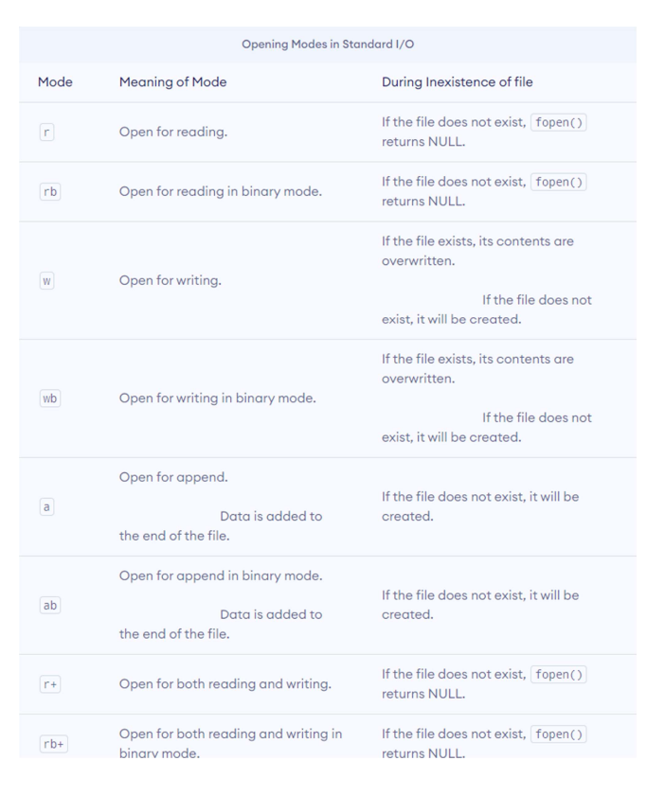

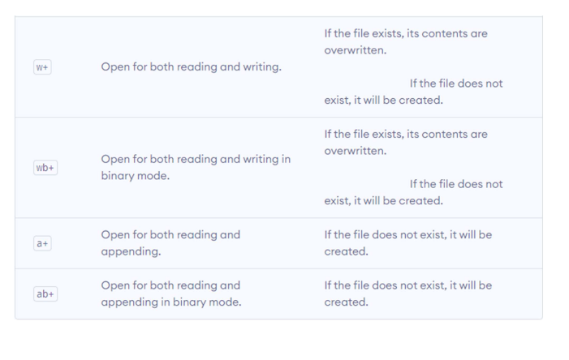

**Closing a File**

**The file (both text and binary) should be closed after reading/writing.**

**Closing a file is performed using the fclose() function.**

**fclose(fptr);**

**Here, fptr is a file pointer associated with the file to be closed.**

**Reading and writing to a text file**

**For reading and writing to a text file, we use the functions fprintf() and fscanf()**

**They are just the file versions of printf() and scanf() . The only difference is**

**that fprintf() and fscanf() expects a pointer to the structure FILE.**

**Example 1: Write to a text file**

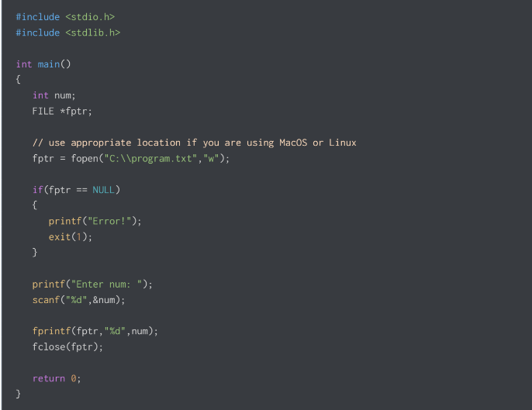

**This program takes a number from the user and stores in the file program.txt.**

**After you compile and run this program, you can see a text**

**file program.txt created in C drive of your computer. When you open the file, you**

**can see the integer you entered.**

**Example 2: Read from a text file**

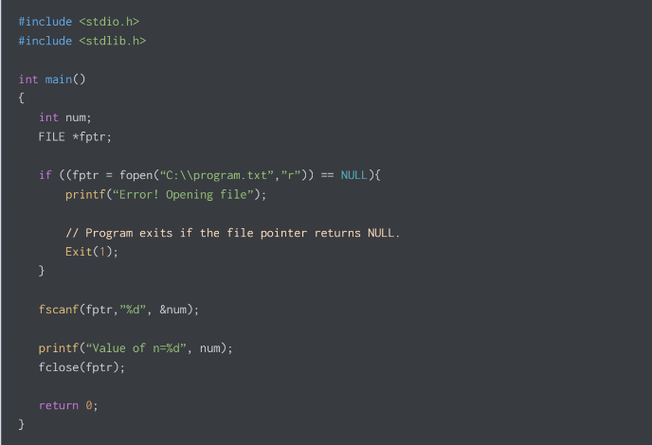

**This program reads the integer present in the program.txt file and prints it onto the**

**screen.**

**If you successfully created the file from Example 1, running this program will get**

**you the integer you entered.**

**Other functions like fgetchar(), fputc() etc. can be used in a similar way.**

**Reading and writing to a binary file**

**Functions fread() and fwrite() are used for reading from and writing to a file**

**on the disk respectively in case of binary files.**

**Writing to a binary file**

**To write into a binary file, you need to use the fwrite() function. The functions**

**take four arguments:**

**1. address of data to be written in the disk**

**2. size of data to be written in the disk**

**3. number of such type of data**

**4. pointer to the file where you want to write.**

**fwrite(addressData, sizeData, numbersData, pointerToFile);**

**Example 3: Write to a binary file using fwrite()**

#include <stdio.h>

#include <stdlib.h>

struct threeNum

{

int n1, n2, n3;

};

int main()

{

int n;

struct threeNum num;

FILE *fptr;

if ((fptr = fopen("C“\\program.bin",”w”")” == NULL){

printf("E“ror! opening file")”

// Program exits if the file pointer returns NULL.

exit(1);

}

for(n = 1; n < 5; ++n)

{

num.n1 = n;

num.n2 = 5*n;

num.n3 = 5*n + 1;

fwrite(&num, sizeof(struct threeNum), 1, fptr);

}

fclose(fptr);

return 0;

}

**Example 4: Read from a binary file using fread()**

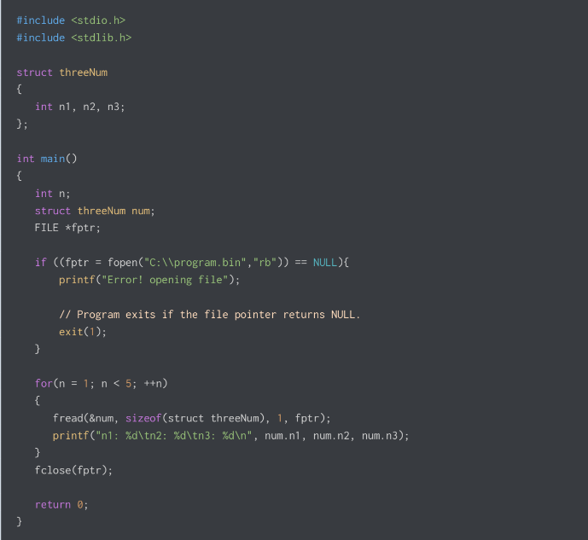

### ****Problems****